**PIZZA SALES SQL QUERIES**

**A.KPI’s**

**1.Total Revenue:**

SELECT SUM(total_price) AS Total_Revenue FROM pizza_sales;

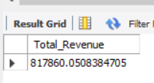

**2.Average Order Value:**

SELECT SUM(total_price)/COUNT(DISTINCT order_id) AS Avg_Order_Value FROM pizza_sales;

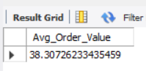

**3.Total Pizza Sold:**

SELECT SUM(quantity) AS Total_Pizza_Sold FROM pizza_sales;

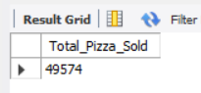

**4.Total Orders:**

SELECT COUNT(DISTINCT order_id) AS Total_Orders FROM pizza_sales;

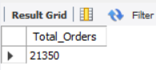

**5.Average Pizzas Per Order:**

SELECT SUM(quantity)/COUNT(DISTINCT order_id) AS Avg_Pizzas_Per_Order FROM pizza_sales;

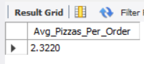

**B.CHART’s**

**1.Daily Trend For Total Orders:**

SELECT DAYNAME(order_date) AS Order_day, COUNT(DISTINCT order_id) AS Total_Orders

FROM pizza_sales GROUP BY DAYNAME(order_date);

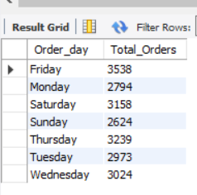

**2.Hourly Trend For Total Orders:**

SELECT DAYNAME(order_date) AS Order_day, COUNT(DISTINCT order_id) AS Total_Orders

FROM pizza_sales GROUP BY DAYNAME(order_date);

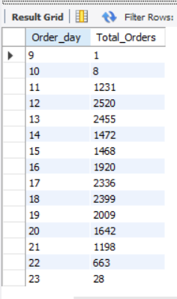

**3.Percentage Of Sales By Pizza Category:**

SELECT pizza_category, SUM(total_price) AS Total_Price, SUM(total_price) * 100 / (SELECT SUM(total_price) FROM pizza_sales WHERE MONTH(order_date) = 1) AS PCT FROM pizza_sales WHERE MONTH(order_date) = 1 GROUP BY pizza_category;

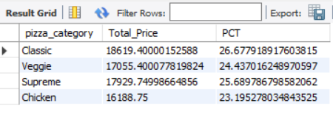

**4.Percentage Of Sales By Pizza Size:**

SELECT pizza_size, ROUND(SUM(total_price),2) AS Total_Price, ROUND(SUM(total_price) * 100 / (SELECT SUM(total_price) FROM pizza_sales WHERE QUARTER(order_date) = 1),2) AS PCT FROM pizza_sales WHERE QUARTER(order_date) = 1 GROUP BY pizza_size ORDER BY PCT DESC;

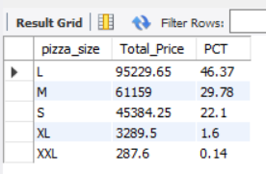

**5.Total Pizzas Sold By Pizza Category:**

SELECT pizza_category, SUM(quantity) AS Total_Pizzas_Sold FROM pizza_sales GROUP BY pizza_category;

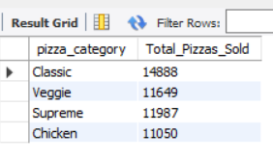

**6.Top 5 Best Sellers By Total Pizzas Sold:**

SELECT pizza_name, SUM(quantity) AS Total_Pizzas_Sold FROM pizza_sales GROUP BY pizza_name ORDER BY Total_Pizzas_Sold DESC LIMIT 5;

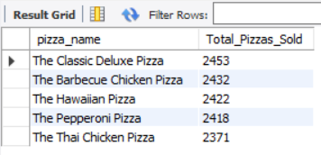

**7.Bottom 5 Worst Sellers By Total Pizzas Sold:**

SELECT pizza_name, SUM(quantity) AS Total_Pizzas_Sold FROM pizza_sales GROUP BY pizza_name ORDER BY Total_Pizzas_Sold LIMIT 5;

